Project Documentation Outline for HealthInsuranceMGMT

**Purpose of the System:**

The HealthInsuranceMGMT e-project is designed as a transformative online health insurance management system, specifically tailored for organizations seeking to streamline health insurance provision for their employees. This system stands at the intersection of technology and healthcare management, intending to bridge the gap between healthcare providers, insurance companies, and employees.

At its core, HealthInsuranceMGMT aims to automate and simplify the entire process of health insurance management. From maintaining comprehensive employee health records to handling insurance claims and settlements, the system is engineered to offer a seamless, integrated experience. By leveraging the capabilities of Customer Relationship Management (CRM) and Content Management System (CMS) technologies, the project ensures that every interaction and piece of information is managed efficiently, securely, and effectively.

Beyond mere automation, HealthInsuranceMGMT embodies a commitment to user-centric design, ensuring that the system is accessible, intuitive, and responsive to the needs of all stakeholders involved. The goal is to eliminate the cumbersome, manual workload traditionally associated with health insurance management, thereby enhancing operational efficiency, security, and reliability. Ultimately, the project seeks to foster a healthier, more informed, and well-supported employee base, underpinning the organizational commitment to employee well-being and satisfaction.

**Problem Definition:**

The existing system for managing health insurance within organizations is fraught with inefficiencies and limitations. Predominantly manual or semi-automated, it confines operations to single-system dependencies, resulting in a user experience that is far from user-friendly. The manual workload not only demands a significant human resource investment but also makes the process time-consuming and prone to errors. Moreover, the current setup struggles to maintain and secure employee-specific information, including policy details, which is paramount for personalized health insurance management. The lack of an integrated, automated solution exacerbates these issues, hindering the organization's ability to provide timely and accurate health insurance services to its employees. This situation underscores the pressing need for a comprehensive, secure, and efficient system designed to overcome these challenges and streamline health insurance management processes.

**Customer Requirement Specification (CRS)**

**Client:**

The Organization requiring Health Insurance Management System.

**Business/Project Objectives:**

Develop an integrated online Health Insurance System for efficiently managing employee insurance data, claims, and policy information, providing secure and real-time access to medical services and insurance details.

**Inputs provided by the Client:**

* Detailed employee data and policy requirements
* Insurance company details and associated policy information
* Desired automated processes for insurance management and claims handling

**Outputs from the System:**

* Employee health records and policy information
* Reports on claims, settlements, and employee insurance details
* Secure access to insurance data for employees and administrators

**Processes Involved in the System:**

* Secure login and user authentication
* Employee registration and policy assignment
* Insurance claims processing and report generation

**List of Deliverables:**

* Functional HealthInsuranceMGMT system
* System documentation and user guides
* Training modules for system users

Hardware Requirements:

* Intel Core i3 Processor or higher
* 4 GB Ram or Above
* Color SVGA
* 120 GB Hard Disk Space

**Software Requirements:**

* ASP.NET Core for system development
* Visual Studio 2022
* Database management system for data storage(SQL 2022)
* CRM and CMS integration capabilities
* Git Hub
* Microsoft Windows 10 or Higher
* .Net Framework 6.7 or higher
* Asp .Net MVC Core

**Scope of the Work:**

The Customer Requirement Specification (CRS) for the HealthInsuranceMGMT system delineates the essential functionalities and features demanded by users to ensure an efficient, secure, and user-friendly experience. Key requirements include a robust authentication system to safeguard sensitive employee and policy information, a comprehensive database for storing detailed records of employees, insurance policies, and claims, and an intuitive user interface that facilitates easy navigation and operation for all user roles. Additionally, users require real-time access to policy details, claim status updates, and personalized employee health records. The system must also integrate seamlessly with existing Customer Relationship Management (CRM) and Content Management System (CMS) platforms, enabling administrators to manage content and interactions effectively. Fulfilling these specifications is crucial for developing a system that not only meets but exceeds user expectations, thereby enhancing the overall efficiency and effectiveness of health insurance management within organizations.

**Architecture and Design of the System**

The HealthInsuranceMGMT system is structured into three primary tiers, each responsible for a specific aspect of the application's functionality. The architecture ensures scalability, maintainability, and security, catering to the diverse needs of the users.

**Presentation Tier (HTML/ASP.NET MVC and MVC CORE):**

This tier forms the user interface of the HealthInsuranceMGMT system, where the system's functionalities are made accessible to the users through a web browser. It has been crafted using HTML and the robust ASP.NET MVC framework to ensure a responsive design that adapts to various devices like desktops, laptops, and tablets.

**Middle Tier/Business Logic Layer (ASP.NET MVC and MVC CORE):**

Sitting at the heart of the system, the middle tier processes the business logic. It is where user requests are authenticated, input is validated, and appropriate responses are generated. This tier ensures seamless interaction between the presentation and database tiers, handling all application operations, data processing, and business rule implementation.

**Database Tier (MS SQL SERVER 2019):**

The database tier is the data repository for the HealthInsuranceMGMT system. It securely stores all data, including employee profiles, insurance policies, and claim details. Powered by MS SQL Server 2019, this tier is optimized for high performance, reliability, and integrity of the health insurance management data.

**Data Flow Diagram (DFD):**

**Image:  
 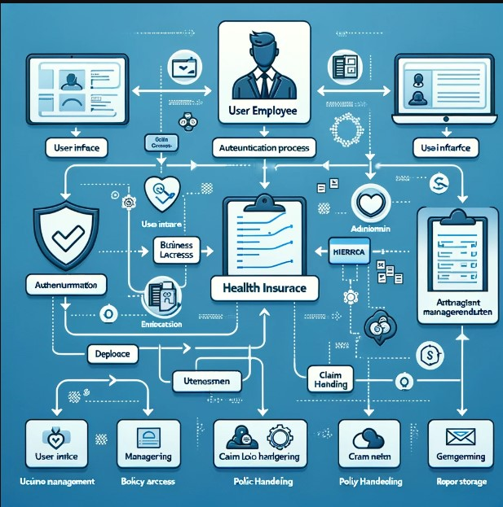**

**The Description for the DFDS’s**

**User (Employee/Admin):**

Think of them as the people who need to use the system. Employees can view and select insurance policies, file claims, etc., while Admins oversee the entire process, manage data, and ensure everything runs smoothly.

**User Interface:**

This is the face of the system, the screen where users interact with the program. It’s designed to be straightforward so that users can find what they need without hassle.

**Authentication Process:**

Just like a bouncer at a club checks your ID, the authentication process makes sure only registered users can enter and use the system. It’s a security check to protect sensitive information.

**Business Logic Processing:**

Imagine this as the brain of the system where all the major decision-making happens. Based on what the user wants to do, it processes requests, like finding the right insurance policy or updating a user's details.

**Database Access:**

This is the system’s library of all information. When the business logic decides what information it needs, it goes here to fetch it, like looking up policy details or retrieving an employee's claim history.

**Policy Management:**

It’s a virtual filing cabinet for all the insurance policies. Users can sift through to find policies that suit their needs, and admins use it to add or update policy details.

**Claim Handling:**

When an employee needs to report a claim, this part takes over. It's like a customer service desk, guiding the claim through the necessary steps until it’s resolved.

**Report Generation:**

This can be seen as a personal assistant that compiles all sorts of reports for the Admins, like summaries of claims filed in a month or which policies are most popular.

**Data Storage:**

A secure vault where all the system’s information is safely stored. It holds everything from user details to entire records of all transactions and activities within the system.

The DFD shows how these parts interact — like a dance between the system's components, ensuring that the user's experience is smooth, their data is safe, and the Admins can keep everything in check.

**Flowcharts and Entity Relationships**

vfvf

**Database and Models**

**Tables:**

* 1. Admin Login

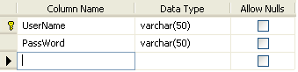

* 1. Company Details

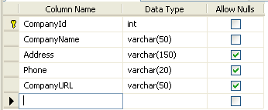

* 1. EmpRegister

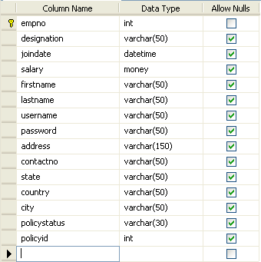

* 1. Hospital Info

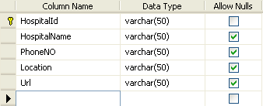

* 1. policies

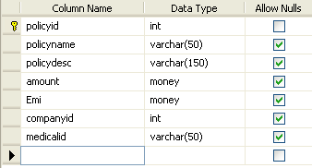

* 1. policies on employees

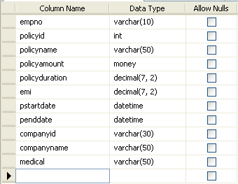

* 1. Policy Approval Details

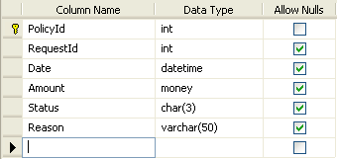

* 1. PolicyRequestDetails

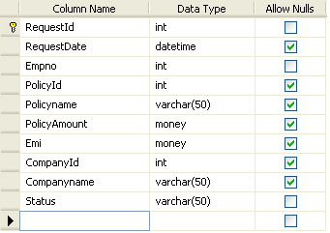

* 1. PolicyTotalDescription:

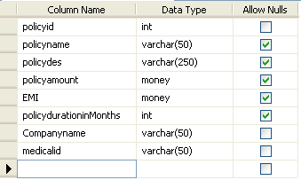

Health Insurance Management System

|  |  |  |  |
| --- | --- | --- | --- |
| Supervisor: | | Sir Zaman Ghani | |
| Batch: | | 2209E 01 | |
| Group: | | Health Insurance Mgmt. | |
| Serial No. | Enrollment No. | | Student Name |
| 1. | 1413911 | | Syed Kashan Abbas Naqvi |
| 2. | 1422404 | | Zayaan Zubair |
| 3. | 1413909 | | Asghar Abbas |
| 4. | 1423235 | | Ali Shan |
| 5. | 1413884 | | Waleed |

Contributions of All Members

|  |  |  |  |
| --- | --- | --- | --- |
| Project: Health Insurance MGMT | | Date of preparation of activity plan | |
| No. | Responsibility | | Student Name |
| 01. | Backend (C#,Asp.net) | | Syed Kashan Abbas Naqvi ,Asghar Abbas |
| 02. | SQL Models | | Zayaan Zubair |
| 03. | Frontend | | Waleed,Ali Shan,S.Kashan Abbas Naqvi |
| 04. | Documentation and User Guide | | Syed Kashan Abbas Naqvi |

|  |  |
| --- | --- |
| Actual Start Date | Actual Days |
| 28-Feb-2024 | 14 Days |